* **Google Maps in Android**

Android allows us to integrate [Google Maps](https://abhiandroid.com/programming/googlemaps/) in our application. For this Google provides us a library via Google Play Services for using maps. In order to use the [Google Maps](https://abhiandroid.com/programming/googlemaps/) API, you must register your application on the **Google Developer Console** and enable the API.



**Steps For Getting The Google Maps Api Key:**

An API key is needed  to access the [Google Maps](https://abhiandroid.com/programming/googlemaps/) servers.  This key is free and you can use it with any of your applications. If you haven’t created project, you can follow the below steps to get started:

**Step 1:** Open Google developer console and signin with your gmail account: <https://console.developers.google.com/project>

**Step 2:**Now create new project. You can create new project by clicking on the **Create Project** [button](https://abhiandroid.com/ui/button/) and give name to your project.

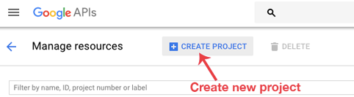

**Step 3:** Now click on APIs & Services and open **Dashboard** from it.

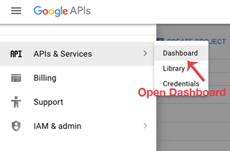

**Step 4:** In this open **Enable APIS AND SERICES**.

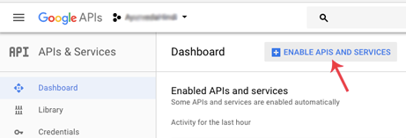

**Step 5:** Now open Google Map Android API.

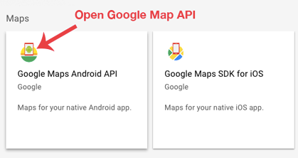

**Step 6:** Now enable the Google Maps Android API.

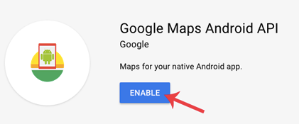

**Step 6:** Now go to**Credentials**

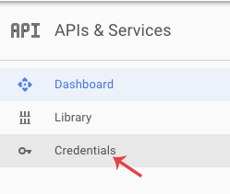

**Step 7:** Here click on Create credentials and choose API key

**Step 8:** Now API your API key will be generated. Copy it and save it somewhere as we will need it when implementing Google Map in our Android project.

#### ****Google Maps Example****

**Step 1: Add Google Maps SDK Dependency**

gradle

dependencies {

implementation 'com.google.android.gms:play-services-maps:18.0.2'

}

**Step 2: Get a Google Maps API Key**

1. Visit **Google Cloud Console**.
2. Create a new project and enable **Maps SDK for Android**.
3. Generate an **API Key**.
4. Add the key to AndroidManifest.xml:

<meta-data

android:name="com.google.android.geo.API_KEY"

android:value="YOUR_API_KEY"/>

**Step 3: Add a Map Fragment to Your Activity**

<fragment

android:id="@+id/map"

android:name="com.google.android.gms.maps.SupportMapFragment"

android:layout_width="match_parent"

android:layout_height="match_parent"/>

**Step 4: Load the Map in Java**

public class MapsActivity extends FragmentActivity implements OnMapReadyCallback {

private GoogleMap mMap;

@Override

protected void onCreate(Bundle savedInstanceState) {

super.onCreate(savedInstanceState);

setContentView(R.layout.activity_maps);

SupportMapFragment mapFragment = (SupportMapFragment) getSupportFragmentManager().findFragmentById(R.id.map);

mapFragment.getMapAsync(this);

}

@Override

public void onMapReady(GoogleMap googleMap) {

mMap = googleMap;

LatLng location = new LatLng(-34, 151);

mMap.addMarker(new MarkerOptions().position(location).title("Marker in Sydney"));

mMap.moveCamera(CameraUpdateFactory.newLatLngZoom(location, 10));

}

}